# Project Geo-app-db

**Node.js, Express & MySQL Tutorial - Build a Simple FullStack App**

<https://www.youtube.com/watch?v=vrj9AohVhPA>

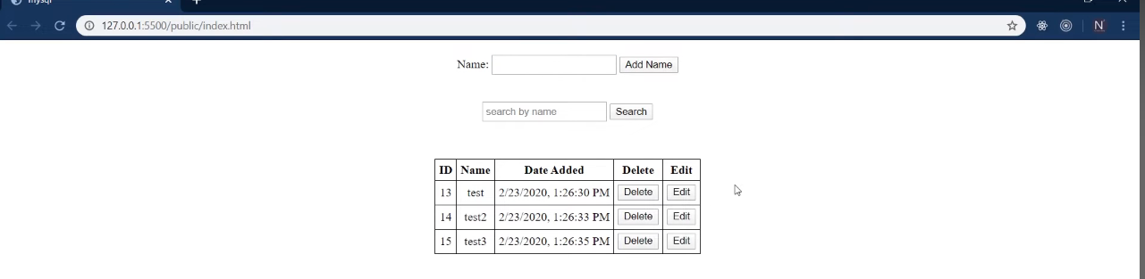

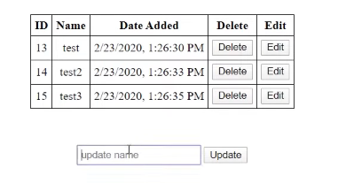 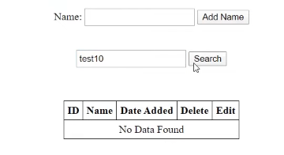

Install xamp to start mysql server

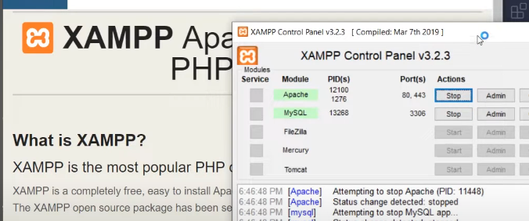

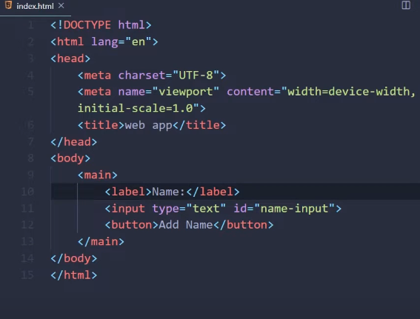

Centre the webpage

Add search and table

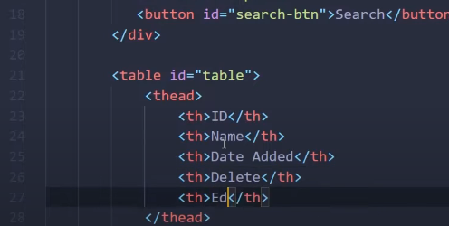

Centralise the contentapply css

Add tbody – will dynamically insert content using js

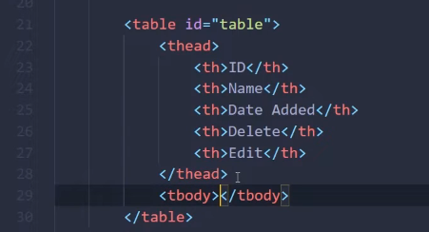

JS >> when the page loads show all data from db but when no data show nodata

No data spans across 5 cols

Work on the backend

Install cors so that we can make API calls from front end to backend



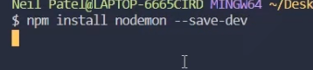

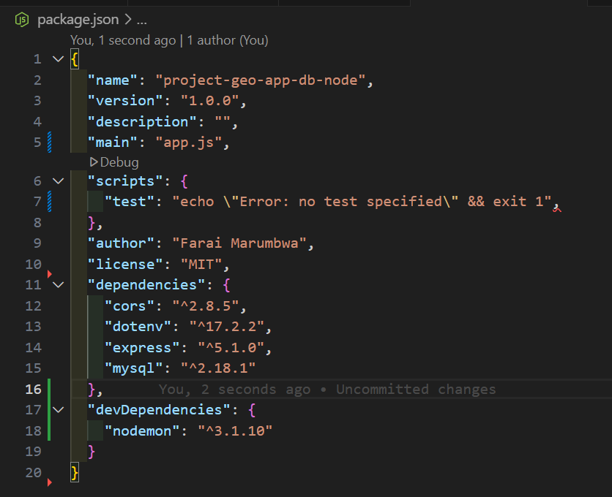

Update since main and add start

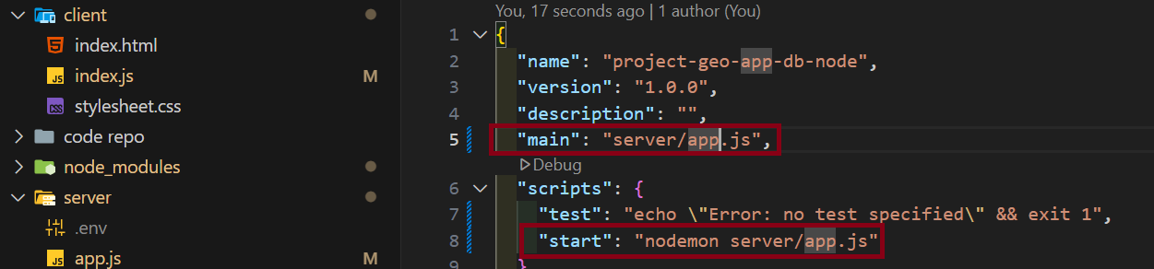

To run 

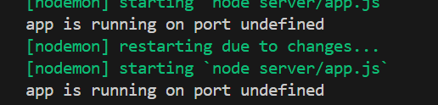

Since the .env is not on root confi the dir and put it on top

Create.env and store the port

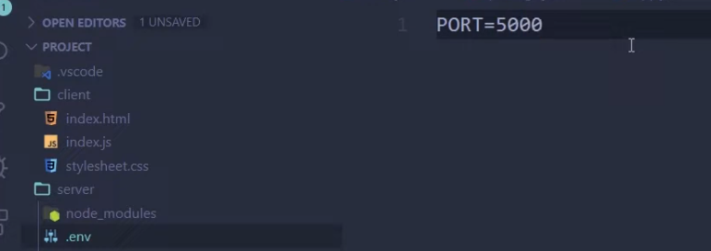

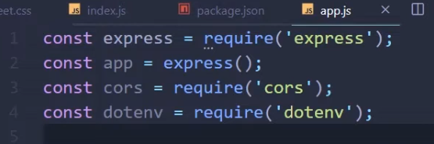

Line8 to send data as json, line 9 to send data from form

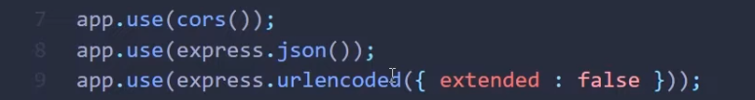

Create routes for create, read delete, update,

Read route > start the server

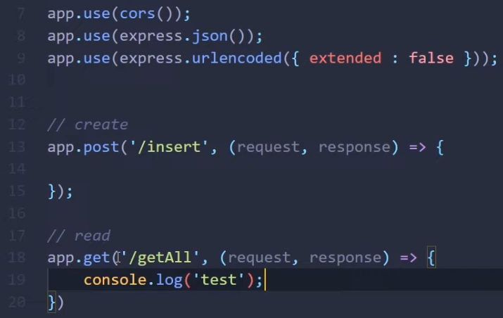 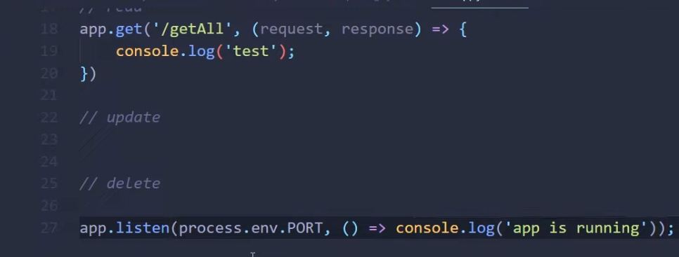

>> run the server >> cd to the server directory

 or



Run the route



>> this prints a test in console nothing print on the html == our backend is working

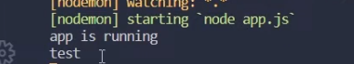

>> Display msg on the browser using send

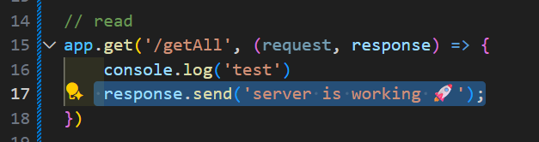

Now work on the front end

>> add fetch api call to db

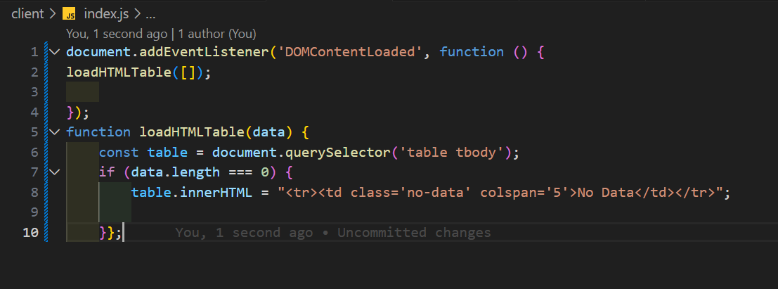

>> add db and connect to it

Change port if there is clash change port in the Xampp/tomcat/config/server.xml lin69

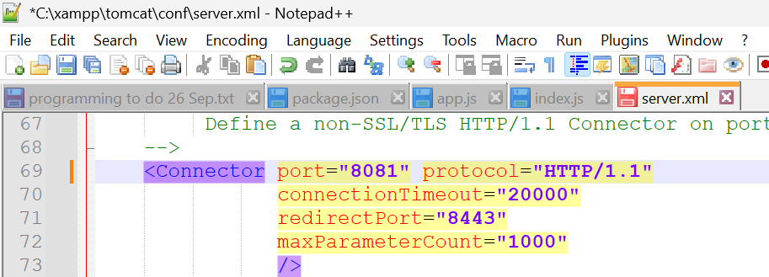

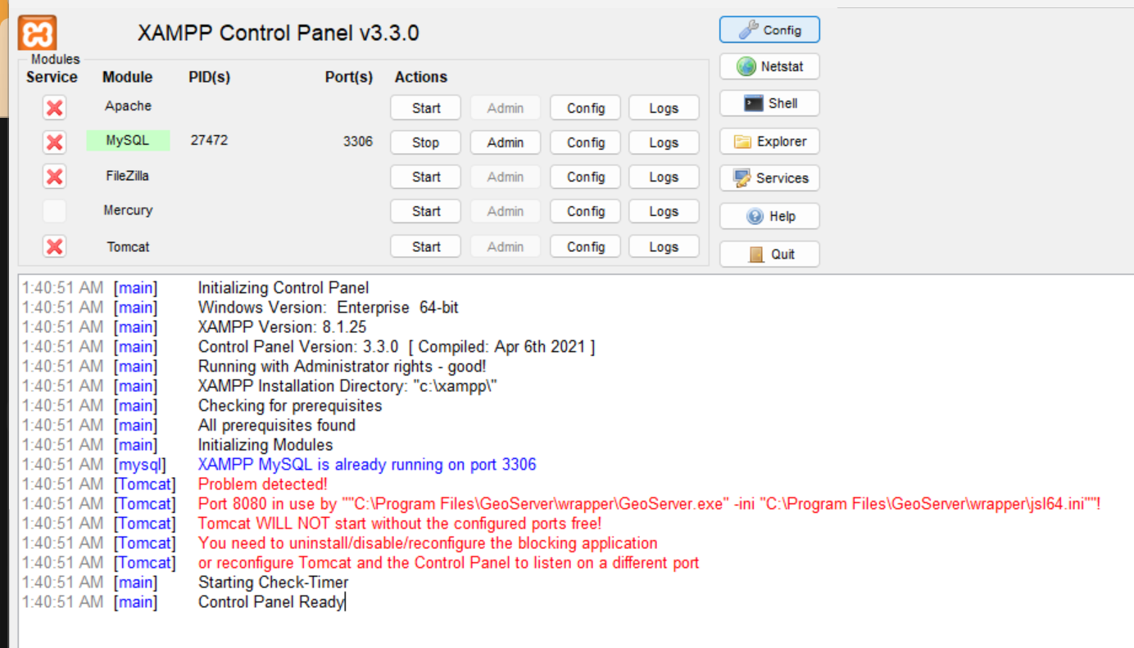

>> tomcat>>config >> server.xml

Also change in xampp main settings >> select tomcat

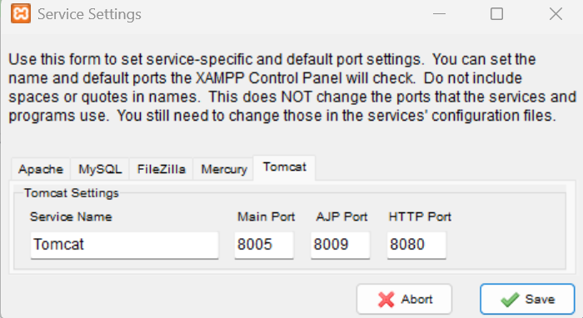

>> start apache and tomcat otherwise mysqlwill fail

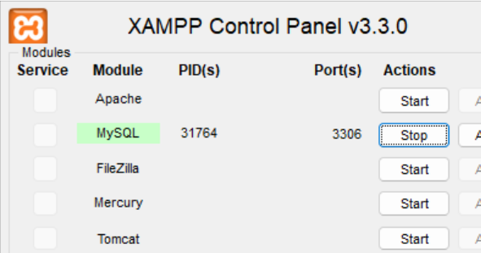

Create db >> click on admin to get the mysql panel

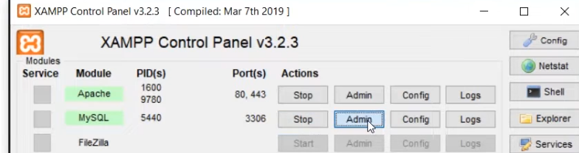

>> take note of port 3306

>> go to admin >> create db For Unicode doent matter what u pick

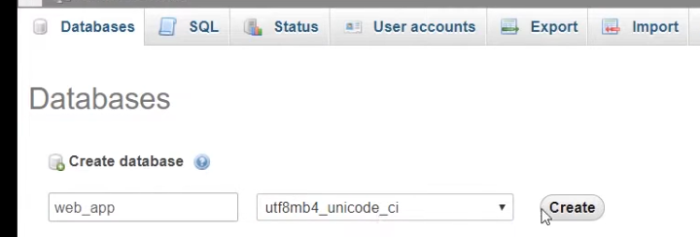

>> Create table

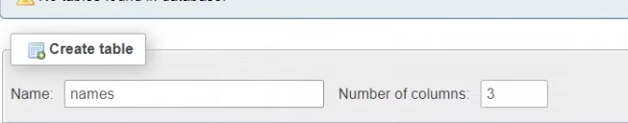

Addcols

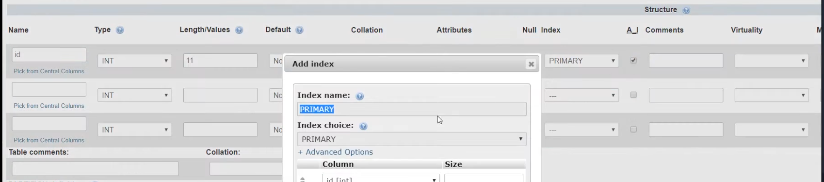

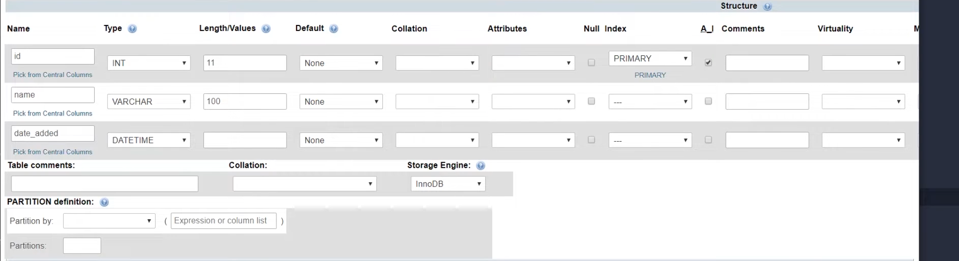

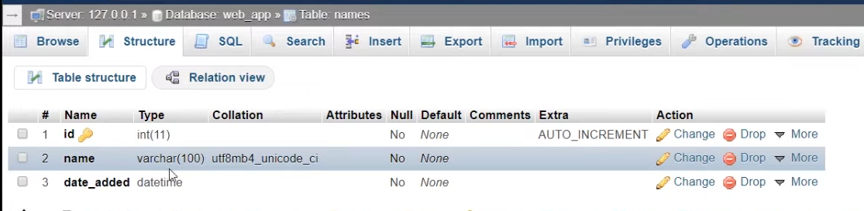

Need to add privileges like user name psswd and acc type

>> Priviledges >>add new user >> don’t click generate

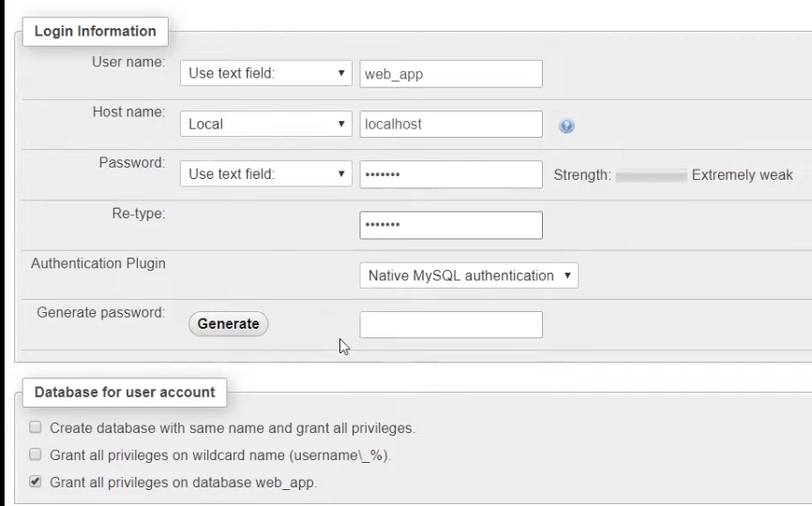

Username faraimax ; password -faraimax

Leave all defaults and click ok

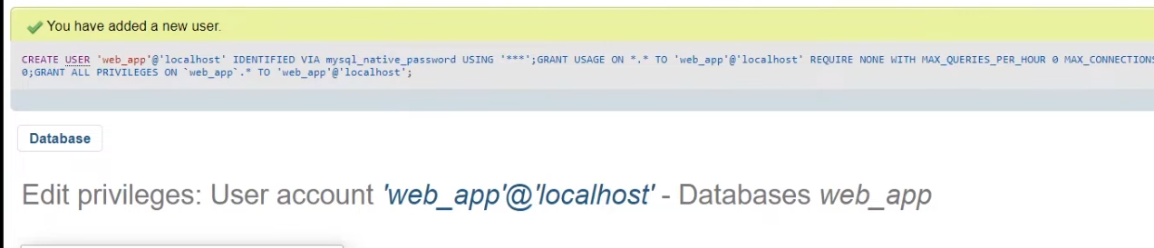

Now addthe db credentials in the .env

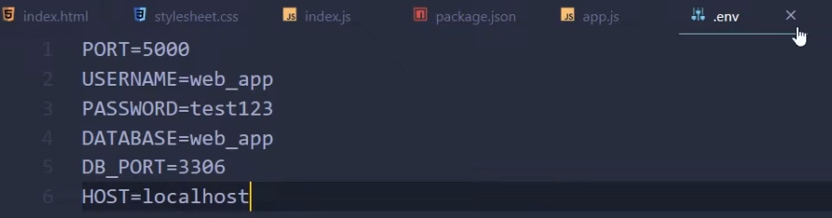 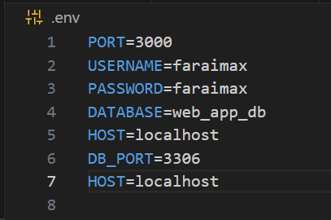

Create a file that’s acts as a service to connect to our db and also do queries

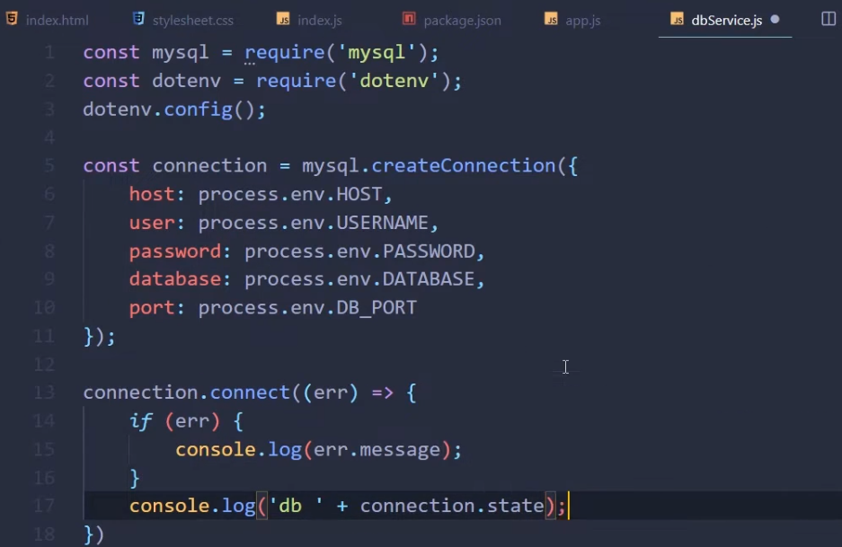

Now include the db service in the app.js

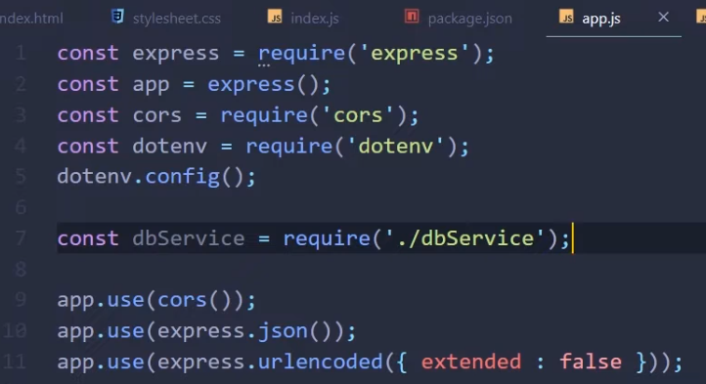

Once dbService is integrated the db will connect



This should be USER and not USERNAME

In the dbService.js create a crud class to handle data transactions